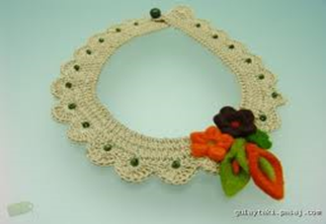[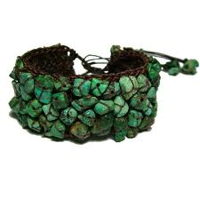](http://www.google.nl/imgres?sa=X&biw=1000&bih=484&tbm=isch&tbnid=qwbFWhKW4lufkM%3A&imgrefurl=http%3A%2F%2Fwww.laachar.com%2Forgu-takilar-tig-isi-kupe-kolye-yapimi-1%2F&docid=R8WwMRsoS0imlM&imgurl=http%3A%2F%2Fwww.laachar.com%2Fwp-content%2Fuploads%2F2013%2F10%2Forgu-takilar-tig-isi-kupe-kolye-yapimi-1-24.jpg&w=600&h=597&ei=Vn_yUvbFJKmk0QXdz4CoCQ&zoom=1&ved=0CHsQhBwwDA&iact=rc&dur=2570&page=2&start=10&ndsp=14)

[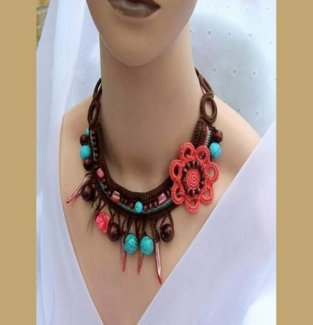](http://www.kadininsitesi.com/orgu-kolye-modelleri-2014.html/tig-isi-kolye-modelleri-2)[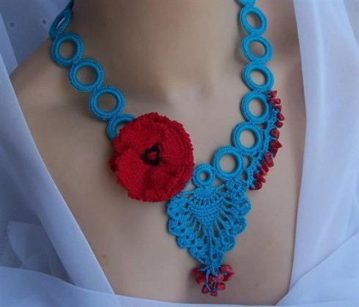](http://www.kadininsitesi.com/orgu-kolye-modelleri-2014.html/tig-isi-kolye-ornekleri-2)

[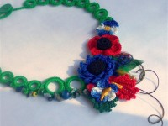](http://www.kadininsitesi.com/orgu-kolye-modelleri-2014.html/orgu-taki-ornekleri-2014)[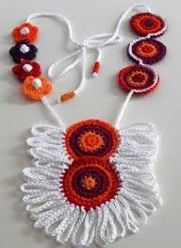](http://www.google.nl/imgres?sa=X&biw=1000&bih=484&tbm=isch&tbnid=OQCJg49djhiwxM%3A&imgrefurl=http%3A%2F%2Fwww.modadekorasyonu.net%2Fel-yapimi-bayan-kolye-modelleri.html%2Ftig-isi-turuncu-bordo-beyaz-el-yapimi-bayan-kolye-modeli&docid=sCWvqkv1etQvrM&imgurl=http%3A%2F%2Fwww.modadekorasyonu.net%2Fwp-content%2Fuploads%2FT%2525C4%2525B1%2525C4%25259F-i%2525C5%25259Fi-turuncu-bordo-beyaz-el-yap%2525C4%2525B1m%2525C4%2525B1-bayan-kolye-modeli-401x550.jpg&w=401&h=550&ei=Vn_yUvbFJKmk0QXdz4CoCQ&zoom=1&ved=0CPYBEIQcMDI&iact=rc&dur=830&page=4&start=38&ndsp=15)[](http://www.google.nl/imgres?sa=X&biw=1000&bih=484&tbm=isch&tbnid=IQwa0ZezXHzxEM%3A&imgrefurl=http%3A%2F%2Fkevserteyze.com%2Fetiket%2Fkolye-ornekleri&docid=GpasLCr-lFoJHM&imgurl=http%3A%2F%2Fkevserteyze.com%2Fwp-content%2Fuploads%2F2011%2F10%2Ft%2525C4%2525B1%2525C4%25259F-i%2525C5%25259Fi-kolye-modelleri5.jpg&w=570&h=473&ei=Vn_yUvbFJKmk0QXdz4CoCQ&zoom=1&ved=0CMQCEIQcMEw&iact=rc&dur=1584&page=6&start=68&ndsp=15)[](http://www.google.nl/imgres?start=299&sa=X&biw=1000&bih=484&tbm=isch&tbnid=ZCaKroYVUiE7vM%3A&imgrefurl=http%3A%2F%2Fmeryemcemurat.blogcu.com%2Ftig-isi-kolye%2F3990742&docid=T2n21A6x7S5bIM&imgurl=http%3A%2F%2Fimg2.blogcu.com%2Fimages%2Fm%2Fe%2Fr%2Fmeryemcemurat%2Fcolcor4.jpg&w=300&h=400&ei=poLyUs3tFuiY1AWjl4CIBg&zoom=1&ved=0CAUQhBwwADisAg&iact=rc&dur=2839&page=22&ndsp=15)[](http://www.google.nl/imgres?sa=X&biw=1000&bih=484&tbm=isch&tbnid=MiWIqoTtgM-_rM%3A&imgrefurl=http%3A%2F%2Fwww.hobidenizi.com%2Ftag%2Ftig-isi-kolye-yapimi%2F&docid=sJxzEetWjLulYM&imgurl=http%3A%2F%2Fwww.hobidenizi.com%2Fwp-content%2Fuploads%2F2013%2F03%2Ftig-isi-kolye-yapimi.jpg&w=360&h=360&ei=Vn_yUvbFJKmk0QXdz4CoCQ&zoom=1&ved=0CPMBEIQcMDE&iact=rc&dur=1570&page=4&start=38&ndsp=15)[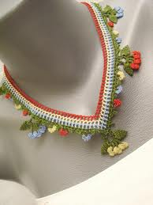](http://www.google.nl/imgres?sa=X&biw=1000&bih=484&tbm=isch&tbnid=h8OQncI7BT7RWM%3A&imgrefurl=http%3A%2F%2Fwww.frmlord.com%2Fel-orgu-ornekleri-ve-modeller%2F78046-sik-zarif-tig-isi-kolye-modeli.html&docid=zL71DFNe72WEiM&imgurl=http%3A%2F%2Fny-image0.etsy.com%2Fil_fullxfull.249395952.jpg&w=768&h=1024&ei=Vn_yUvbFJKmk0QXdz4CoCQ&zoom=1&ved=0CH4QhBwwDQ&iact=rc&dur=3711&page=2&start=10&ndsp=14)[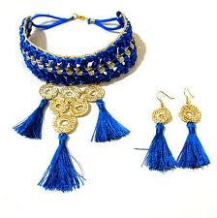](http://www.google.nl/imgres?start=210&sa=X&biw=1000&bih=484&tbm=isch&tbnid=i_m0X3JQGCxU2M%3A&imgrefurl=http%3A%2F%2Fwww.bakimliyiz.com%2Ftaki-ve-aksesuar-modasi%2F71878-tig-isi-kolye-ve-kupe-modeli.html&docid=yI3telaJhuT0mM&imgurl=http%3A%2F%2Fwww.10marifet.org%2Fimaj%2Fsesiber%2Fsany0013-2.JPG&w=456&h=460&ei=TYLyUsyXKsKM0AXbloHYBQ&zoom=1&ved=0CE0QhBwwGDjIAQ&iact=rc&dur=1746&page=16&ndsp=16)[](http://www.kadininsitesi.com/orgu-kolye-modelleri-2014.html/orgu-kolye-modelleri-3)[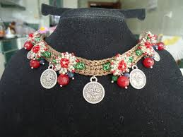](http://www.google.nl/imgres?start=126&sa=X&biw=1000&bih=484&tbm=isch&tbnid=5RQsucO20JHbiM%3A&imgrefurl=http%3A%2F%2Femeksensin.com%2Fultrangelica21%2Fboncuk-oyali-tig-isi-otantik-tasma-kolye-137005&docid=3bkJ_B-ZNib8-M&imgurl=http%3A%2F%2Fd1ncmh33x7chgg.cloudfront.net%2Feresim%2F137005%2F5lijsmtjg75f217sihjlcn.jpg&w=600&h=450&ei=qIDyUvfSE4TX0QWX1oGoAg&zoom=1&ved=0CGsQhBwwIjhk&iact=rc&dur=1288&page=10&ndsp=14)